Emotion Classification with Machine
Learning
Machine Learning · NLP · Emotion Analysis

Introduction

The objective of this project was to develop and evaluate machine learning models capable of classifying text into different emotion categories; useful for social media analysis, customer feedback systems, and mental health monitoring.
The dataset consisted of text samples associated with one of seven emotion classes: happiness, sadness, hate, worry, fun, surprise, and neutral. The goal was to identify the most suitable machine learning model for this classification problem and measure its performance using evaluation techniques. To achieve this, we implemented, trained, and compared models: k-Nearest-Neighbours, Support Vector Machine, Decision Tree, Neural Network, and Naïve Bayes.

Data Preprocessing and Feature Engineering

Raw text data cannot be directly used by machine learning algorithms, so a preprocessing pipeline was implemented to convert textual data into numerical features. The following steps were applied:
- Conversion of all text to lowercase.
- Expansion of contractions (e.g., "don't" → "do not").
- Removal of punctuation and special characters.
- Removal of common stopwords.
- Lemmatization to reduce words to their base forms.
- Vector transformation (via TF-IDF)
Developers’ Note: A maximum vocabulary size of 5,000 was selected to balance model performance and computational cost, while anything greater would show signs of overfitting.

Experiment Setup

The dataset was divided into 80/20 training/testing split. Stratified sampling was used to ensure each emotion class maintained approximately the same distribution in both subsets. The models were evaluated under an identical TF-IDF representation, with the primary evaluation metric being accuracy. Precision, recall, and F1-score were also included for posterity.

Experimental Results

This table summarises the classification accuracy of each model:
Model | Accuracy
k-Nearest Neighbors | 71.88%
Naive Bayes | 82.63%
Decision Tree | 83.63%
Neural Network (Multi-Layer Perceptron) | 88.31%
Support Vector Machine | 90.56%

kNN achieved the lowest performance, which is expected because high-dimensional TF-IDF spaces reduce the effectiveness of distance-based methods.
Naive Bayes was limited in its ability to model complex word relationships due to assuming word independence.
Decision Tree struggled to generalize what it learned.
Neural Network (MLP) performed well, but took magnitudes more time and computation power than the other models.
Support Vector Machine consistently achieved the highest accuracy with balanced precision, recall, and F1-scores.

Model Validation

To further validate the SVM, 5-fold cross-validation was performed, with results demonstrating consistent performance across folds with low variation, confirming that the model generalised well and did not depend on any particular train-test split.
A confusion matrix was also generated. Most predictions were concentrated along the diagonal, indicating correct classification. Misclassification mainly occurred between naturally similar emotions such as sadness and worry.
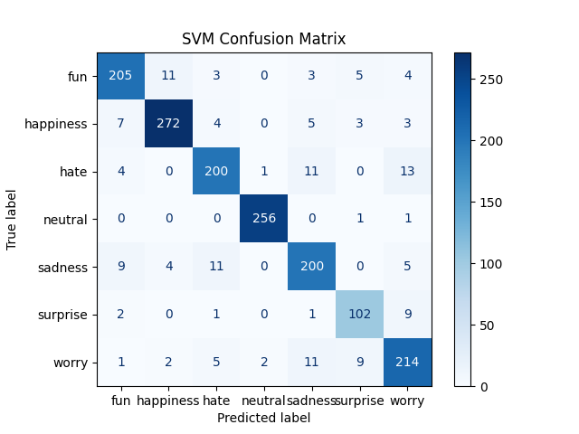

Summary

This project investigated machine learning techniques for emotion classification in text. Several models were evaluated using a common TF-IDF. Experimental results showed that Support Vector Machines outperformed all other approaches, achieving approximately 90.56% classification accuracy, and providing an effective balance between performance, and implementation complexity. Additional validation through 5-fold cross-validation and confusion matrix analysis confirmed the model to be robust.

Credits

This project and report are brought to you by the following UNIC students:
U241N0057 - Dorian Hare
U244N0036 – Erol Barabar
U244N2631 – Manish Shrivastav
GitHub Repo: https://github.com/maneeshshrivastav/ML_Project_2nd_year

